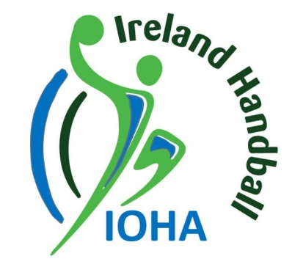
NOTICE OF MEETING
The Annual General Meeting of
The Irish Olympic Handball Association will be held

On Sunday, December 4th, 2022, at 12.00 noon.
In
The Pearce and Connolly Room
At The Hilton Hotel
Kilmainham, Dublin 8.

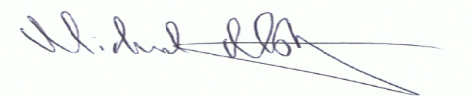
Michael Moloney
Secretary
Irish Olympic Handball Association
October 30th^{th}, 2022.

The Board of the Irish Olympic Handball Association wish to announce that Mr. Darren Connolly has stepped down as Treasurer due to personal reasons. A new independent Director of Finance is being recruited through the Federation of Irish Sport and Board Match.
The Legal Director of the Irish Olympic Handball Association, Mr. Eoin Gallagher has decided not to seek re-election to the Board at the 2022 AGM.
The Secretary of the Irish Olympic Handball Association, Mr. Michael Moloney is seeking re-election and has been nominated by the Board of the IOHA.

Please note the following information
- Any nomination proposed by an Affiliated Club and duly seconded by one or more Affiliated Clubs together with such information as the Board may stipulate shall be notified to the Honorary Secretary in writing not less than 21 days before an Annual General Meeting.
- An incumbent Board Member eligible for re election at an Annual General meeting may be nominated by the Board for re election.
- Each Affiliated Club shall be entitled to nominate only one nomination for election at an Annual General Meeting.
- Any motion put forward by an Affiliated Club and signed by the Chairman and Secretary of that Affiliated Club shall be notified to the Secretary in writing not less than 21 days before an Annual General Meeting. Each motion shall deal with one subject.
- The Board may alter or amend any motion which offends against the Articles of the Association but not otherwise, and may composite any two or more motions which, in the opinion of the Board constitutes in substance the same motion or which deals with the same subject matter and is to the same effect. The Board shall inform, in writing, any Affiliated Club whose motion is altered, amended or composited in accordance with this article and then shall arrange for the final Annual General Meeting Agenda to be prepared and furnished to each person entitled to receipt of notice in accordance with these articles not later than 14 days before the commencement of an Annual General Meeting.

